**Tutorial No. 2**

**Title: Implementation of Control Structures in Python**

**Batch: B1 Roll No: 1914078 Tutorial No.2**

**Aim:** To implement Control Structures in Python.

**Resources needed:** Python IDE

### Theory:

### The sequential flow can be altered in two ways:

### Conditional execution: a block of one or more statements will be executed if a certain expression is true.

### Eg: if, else, else-if

### Repetitive execution: a block of one or more statements will be repetitively executed as long as a certain expression is true.

### Eg: for, while

### Conditional statements of Python are following:

### if statement: Executes a group of statements only if a certain condition is true. Otherwise, the statements are skipped.

### Syntax:

### if *condition/boolean expression*:

### *statements*

### if/else statement: Executes one block of statements if a certain condition is True, and a second block of statements if it is False.

### Syntax:

### if *condition*:

### *statements*

### else:

### *statements*

### if/elif/else statement: If the condition for if is False, it checks the condition of the next elif block and so on. If all the conditions are False, body of else is executed. Only one block among the several if...elif...else blocks is executed according to the condition

### Syntax:

### if *condition*:

### *statements*

### elif *condition*:

### *statements*

### Else:

### *statements*

### Looping structures of Python are following:

### for loop: Repeats a set of statements over a group of valueslike  list, tuple, string or other iterable objects.

### Syntax:

### for *variableName* in *groupOfValues*:

### *statements*

### while loop: Executes a group of statements as long as a condition is True.It is good for *indefinite loops* (repeat an unknown number of times)

### Syntax:

### while *condition*:

### *statements*

### Activity:

1. Write a program for accepting marks of 5 subjects and calculate percentage of marks of students and assign the grades(if elif else). Display error messages if marks are out of range
2. Using a for loop, write a program that prints out the decimal equivalents of 1/2, 1/3, 1/4, . . . ,1/10
3. Write a program using a while loop that asks the user for a number, and prints a countdown from that number to zero

Ans 1)

tot = 0

flag = False

for i in range(5):

    val = int(input("Enter marks scored in subject " + str(i+1)+": "))

    if(val > 100):

        flag = True

        print("Marks cannot be greater than 100")

        break

    tot += val

if not flag:

    print("Average is:", tot/5)

Output:

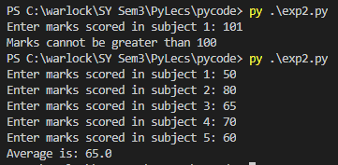

Ans 2)

for i in range(2, 11):

    print("1/"+str(i)+" = "+str(1/i))

Output:

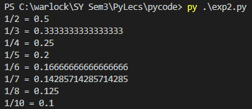

Ans 3)

n = int(input("Enter a number: "))

while(n >= 0):

    print(n)

    n -= 1

print("Completed Countdown")

Output:

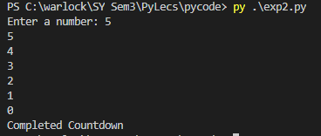

### Post Tutorial Questions:

### Which are the control structures present in other programming languages like C, C++ and Java but not in Python? Can it be implemented in python and mention how?

### Do while is the the control structures present in other programming languages like C, C++ and Java but not in Python. Yes, it can be.

### Do-while syntax:

do {

   //statement

} while (condition);

### Example for doing do while loop which is post check loop in python:

i = 1

while True:

    print(i)

    i = i + 1

    if(i > 5):  break

### Outcomes: Use of Different Decision Making Statements and Functions in Python

**Conclusion:** We implemented Control Structures in Python.

**References:**

1. Reema Thareja , *Python Programing: Using Problem Solving Approach,* Oxford University Press, First Edition 2017, India
2. Dr. R. Nageswara Rao, *Core Python Programming,* Wiley Publication, Second Edition 2018,India
3. Sheetal Taneja and Naveen Kumar, *Python Programing: A Modular Approach,* Pearson India
4. Swarroop C.H, *Byte of python,* e-book, Kindle edition
5. Martin C Brown, *The Complete Reference Python,* Brandon A Nordin, First Edition 2001